**Enhanced Hepatotoxicity after Furan and Cadmium Co-exposure in Rats: Involvement of Oxidative Stress and Apoptotic Cascades**

Shrouk Amer1, Ragab Elshawarby1, Nabila M. Abdelaleem1, Elham Elshewy1, Afaf Abdelkader2, Ahmed B. Zaid3, Ahmed Abdeen1*

1Department of Forensic Medicine and Toxicology, Faculty of Veterinary Medicine, Benha University, Toukh 13736, Egypt; (SA) [Shrouk.azat@fvtm.bu.edu.eg; (RE)](mailto:Shrouk.azat@fvtm.bu.edu.eg;%20(RE)) [RAGAB.ALSHAWARIBY@fvtm.bu.edu.eg](mailto:RAGAB.ALSHAWARIBY@fvtm.bu.edu.eg);(NA) [NABILA.SALAM@fvtm.bu.edu.eg;(EL)](mailto:NABILA.SALAM@fvtm.bu.edu.eg;(EL)) [ELHAM.ALSHIWY@fvtm.bu.edu.eg](mailto:ELHAM.ALSHIWY@fvtm.bu.edu.eg);(AA) [ahmed.abdeen@fvtm.bu.edu.eg](mailto:ahmed.abdeen@fvtm.bu.edu.eg)

2Department of Forensic Medicine and Clinical Toxicology, Faculty of Medicine, Benha University, Benha 13518, Egypt; [afaf.abdelkader@fmed.bu.edu.eg](mailto:afaf.abdelkader@fmed.bu.edu.eg)

3Department of Clinical Pathology, National Liver Institute, Menoufia University, Shibin Elkom 32511, Egypt; [ahmedzaid@liver.menofia.edu.eg](mailto:ahmedzaid@liver.menofia.edu.eg)

**\*Correspondence:** Ahmed Abdeen ([ahmed.abdeen@fvtm.bu.edu.eg](mailto:ahmed.abdeen@fvtm.bu.edu.eg); Tel, +201000222986)

**ABSTRACT**

Furan (FU) and Cadmium (Cd) are toxic agents, and persistent exposure may harm both human and animal health. Therefore, we explored the effects of FU and Cd on liver of the male rat. Male Wister rat groups are distributed randomly: control group (Cr-water): rats were given DI water; control oil group (Cr-oil): rats received corn oil; Furan group: rats received Furan (FU, 16 mg/kg) orally; Cd group: rats obtain cadmium (Cd, 2 mg/kg) orally; and FU+Cd group: rats given both FU +Cd. For 30 days, each therapy was administered once daily. Blood samples and hepatic tissues were obtained after all rats were euthanized. The outcomes showed that treatment with FU or Cd alone considerably caused liver damage, evidenced by serum increase of AST, ALT, ALP, triglycerides, and cholesterol as well as histological changes. Following FU or Cd exposure, there were significant reductions in CAT, GSH, and SOD contents, as well as increases in malondialdehyde along with upregulated expression of PCNA and TNF-α. In contrast, when FU and Cd were administered together potentiated each other and caused more cellular damage in liver tissue. This study found that the primary modulator for enhancing FU and Cd toxicity when administered together was thought to be oxidative stress pathways.

**Keywords:** oxidative stress; PCNA; combined toxicity; TNF-α

**Highlights:**

* FU and/or Cdinducehepatotoxicity.
* Combined exposure to FU and Cd caused higher toxicities to liver tissue than their individual exposure.
* Oxidative stress and inflammatory damage are the main causes of potentiated toxicity.

1. **INTRODUCTION**

Furan (FU) is a volatile, colorless, lipophilic, and aromatic heterocyclic molecule. It is a common industrial thermal processing contaminant that may be found in many cooked or processed foods, such as baby meals that are canned or jarred. Furthermore, it is a part of tobacco smoke and a synthetic intermediate used to make fragrances, artificial medications, herbal treatments, and environmental toxins **(Delost *et al.*, 2018)**. There has been evidence of FU in coffee variants, morning cereals, and baby food that contains meat **(Husøy *et al.*, 2019)** at concentrations exceeding 100 parts per billion **(Kaya *et al*., 2019a)**.Previous studies found that FU adversely affects the biological systems of both humans and animals and causes a variety of cancers **(Uçar and Pandir, 2017)**. FU can be absorbed through the gastrointestinal system, and its removal from the circulation is mostly the responsibility of the liver where it is metabolized by liver cytochrome P450 2E1-mediated ring opening that produces cis-2-butene-1,4-diol (BDA) **(Batool *et al.*, 2021)**. According to **Lu and Peterson (2010)**, it is a highly reactive metabolite of FU that may interact with the amino and thiol groups and other peptides. The bioactivation of FU to BDA leads to ATP loss, which irreversibly decouples oxidative phosphorylation in the mitochondria of the liver. Collectively, cytotoxic enzymes are activated, including endonucleases that split DNA strands. Additionally, FU induced quick and substantial GSH depletion in hepatocytes, and this disruption to the antioxidant defense mechanism within the cell created the circumstances for free radicals to cause cell damage **(Alizadeh *et al.*, 2018)**.

Moreover, the environment is heavily contaminated with Cd, which arises from manufacturing, agriculture, and numerous other sources of pollution along with natural occurrences **(Zhang and Reynolds, 2019)**. For the majority of the population, diet and cigarette use are thought to be their two main contributors **(Rahimzadeh *et al.*, 2017; Zhang and Reynolds, 2019)**. Through the food chain, Cd can build up in fish, birds, and mammals, causing acute and chronic poisoning **(Bao *et al*., 2017)**. Several research investigations have demonstrated that chronic exposure to Cd can result in a range of pathophysiological alterations in the body as well as various organ damage, including kidney, liver, testicular, and pulmonary edema **(Dai *et al.*, 2018; Liu *et al.*, 2018)**.

Although the mechanisms of Cd toxicity at the tissue level in biological systems are not fully understood, numerous pathways have been found to be the means by which Cd manifests its harmful effects on health. One of the most common and significant mechanisms is the imbalance in the antioxidant state that occurs in biological systems following Cd exposure. Free radical production rises, and essential antioxidant enzyme activity is suppressed **(Nair *et al.*, 2013; Sharma, 2014)**. The cellular oxidation-reduction equilibrium can be severely disrupted, resulting in tissue and organ dysfunction **(Poli *et al.*, 2022)**.

Since the liver is a highly perfused organ with a large blood volume, there is strong evidence that it is a target for FU and Cd intoxication **(Amamou *et al.*, 2015; Kaya *et al*., 2019b; Seif *et al.*, 2019; Kumar *et al.*, 2021; Kousar *et al.*, 2022)**. Furthermore, because the liver has an abundance of enzymes that break down xenobiotics, it serves as the primary location for xenobiotic metabolism. Based on the Based on the aforementioned, in many circumstances, FU and Cd are consumed by humans and farm animals through their foods and water, it was important to monitor the level of toxicity following combined exposure to them. To the best of our knowledge, a literature survey divulges that, until date, there is no toxicological investigations about the potential impact of combined exposure to FU and Cd on the liver. Therefore, the current investigation set out to ascertain how FU and/or Cd affected liver function measures, oxidative stress markers, histopathological structure, and immunohistochemistry.

1. **MATERIALS AND METHODS**

**2.1. Chemicals:**

Tetrahydrofuran (CAS No. 109-99-9; 99.5% Extra pure; LOBA CHEMIE PVT.LTD.) was bought from Mumbai, India. The source of CdCl2 was Central Drug House Ltd. in New Delhi, India. The kits utilized for the analyses were purchased from Bio-diagnostics Company in Giza, Egypt.

**2.2. Experimental animals and ethical endorsement:**

Fifty Wister albino male rats weighing between 160-200 g were acquired from the Center of Laboratory Animals, Faculty of Veterinary Medicine, Benha University, Egypt. Prior to the experiment, the rats were housed in metal cages that were adjusted to a temperature of 25 ± 3 °C for 14 days. They also had unlimited access to water and commercial laboratory pellets. The experimental rats complied with the Faculty of Veterinary Medicine's Research Ethical Committee's (BUFVTM 01–05–23) morally acceptable protocols for the care and use of laboratory animals.

**2.3. Experimental design:**

Rats were randomly allocated to five equal experimental groups (n = 6/group). Group 1(Cr-water); received DI water. Group 2 (Cr-oil); received corn oil. Group 3 (FU); received FU at a dose of 16 mg/kg b.w **(McDaniel *et al.*, 2012)**. Group 4 (Cd); received Cd at a dose of 2 mg/kg b.w **(Abdeen *et al*., 2019a)**. Group 5 (FU+Cd); received FU (16 mg/kg b.w) + Cd (2 mg/kg b.w). Every treatment was given orally as described above for 30 days.

**2.4. Sampling:**

After the end of trial, isoflurane was used as an inhalation anesthesia for drawing blood samples from the hepatic vein. After being extracted, the liver tissues were split into two sections. One section was utilized for a histological investigation, while the other was kept in storage at -80 °C for evaluation of oxidative stress indicators.

**2.5. Biochemical assays:**

Clotted blood samples were centrifuged at 4000 rpm for 10 min using a cooling centrifuge (DLAB D3024R High-Speed Micro-Centrifuge, USA) and the serum was taken out and kept at 4 °C for additional biochemical examination including aspartate aminotransferase (AST), alanine aminotransferase (ALT), alkaline phosphatase (ALP), triglycerides (TG), and cholesterol to evaluate liver function. The previous biochemical tests were evaluated in compliance with the given data process using commercial kits from the Laboratory Biodiagnostics Company in Giza, Egypt.

**2.6. Evaluation of oxidative stress markers:**

one g of hepatic tissue in 5 ml of cold buffer solution (50 mmol K3PO4, 1 mmol EDTA, pH 7.5) was thoroughly mixed using a sonic homogenizer. A cooled centrifuge was used to centrifuge the resultant homogenate for 20 min at 4000 rpm. The supernatant was collected and utilized to assess malondialdehyde (MDA) and glutathione (GSH)contents as well as the activities of catalase (CAT) and superoxide dismutase (SOD). All procedures were performed according to the manufacturer’s protocols.

**2.7. Histopathological alteration:**

Fresh liver tissues were cut into slices that were 3–4 mm thick. These slices were then fixed in 10 % neutral buffered formalin (10 % NBF), dried in ethanol at different concentrations, washed in xylene, and processed using the typical paraffin-embedding method. After sectioning paraffin blocks at a thickness of 4-6 m, they were deparaffinized and then stained with hematoxylin and eosin (H&E) for histological changes. Hepatocellular tissue was examined under a Leica microscope (CH9435 Hee56rbrugg) supplied by Leica Microsystems in Switzerland.

**2.8. Immunohistochemistry:**

For immunohistochemical examination, liver sections from each group under study were deparaffinized, dehydrated in graded ethanol solutions, and fixed on positively charged slides by using avidin-biotin- peroxidase complex (ABC) method. Liver section was pre-incubated with a Mouse Anti-TNF alpha Monoclonal Antibody (Elabscience Cat# E-AB-22159, Dilution: 1:50), and another section was pre-incubated with Rabbit Anti PCNA Polyclonal Antibody, (Elabscience Cat# E-AB-64562, dilution; 1:50) antibodies before being treated with the reagents needed for the ABC technique (Vectastain ABC-HRP kit, Vector labs). Marker expression was found using peroxidase and stained with diaminobenzidine (DAB, Sigma) to distinguish antigen-antibody complexes. Instead of primary or secondary antibodies, negative controls were implemented using non-immune serum. Using a Leica microscope (CH9435 Hee56rbrugg) (Leica Microsystems, Switzerland) with various magnification powers, immuno-stained slices were examined and taken as photographs.

**2.9. Statistical data:**

The statistical program SPSS (Version 20.0; SPSS Inc., Chicago, IL, USA) was used for all statistical analyses. The considerable divergence across several groups was analyzed using one-way ANOVA and Duncan's post hoc test. Every value is shown as mean ± standard error (SE) and deemed significant at P < 0.05.

**3. RESULTS**

**3.1. Biochemical analyses:**

As shown in **Figure 1,** FU, Cd, and FU+Cd groups caused hepatoxicity demonstrated by an increase in serum liver indicators. In comparison to control animals, there was a significant rise in AST, ALT, and ALP activity. Furthermore, we found that, in contrast to control rats, there were significant increases in the amounts of TG and cholesterol in the serum. These findings revealed that the synergistic action of FU and Cd together caused greater liver damage in rats than did either one alone.

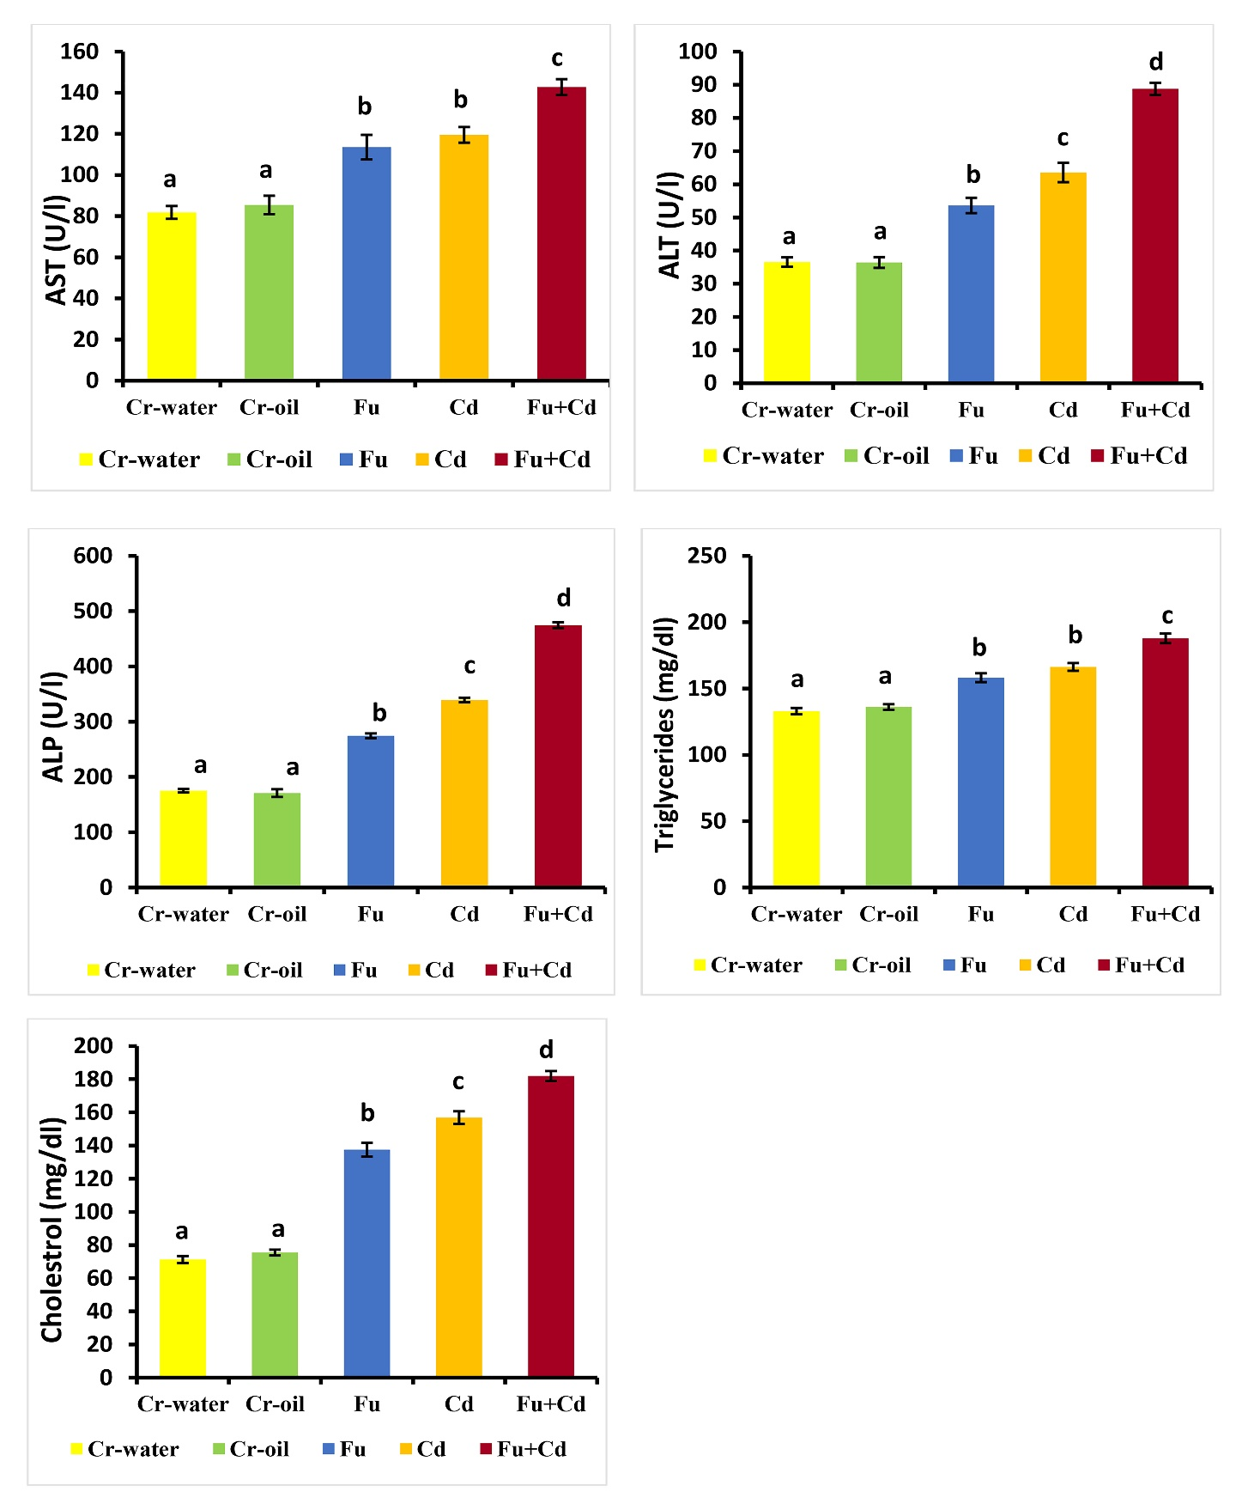**Figure 1.** Changes in serum biochemical parameters after treatment with FU and/or Cd. All values are represented as the mean ± SE (n = 6). AST, aspartate aminotransferase; ALT, alanine aminotransferase; ALP, alkaline phosphatase; FU, Furan; Cd, Cadmium

**3.2. Oxidative/antioxidative biomarkers assay**

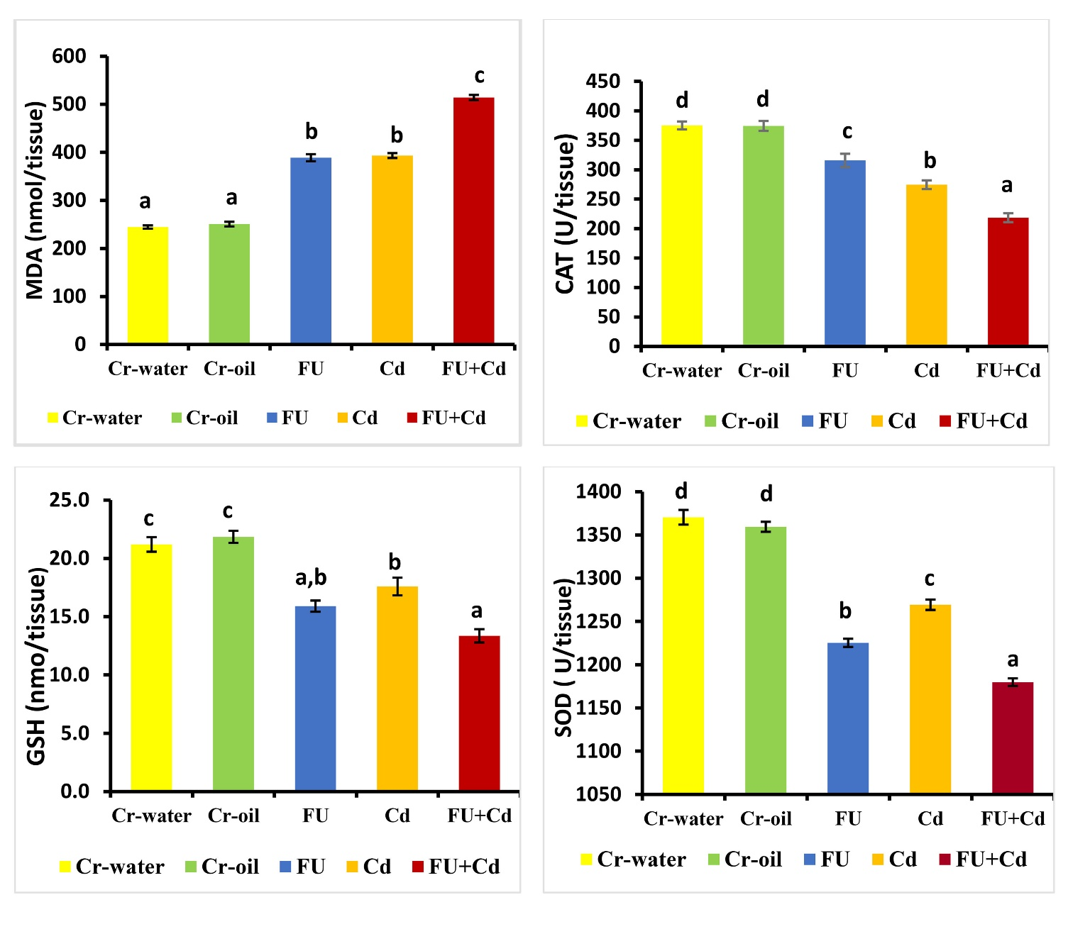The effects of FU, Cd, and FU+Cd intoxication on lipid peroxidation and liver oxidative parameters are displayed in **Figure 2**, treatment with FU and Cd resulted in significant oxidative stress, which was accompanied by a marked decrease in CAT, GSH, and SOD activity in the hepatic tissue relative to the control group. MDA levels increased dramatically. Remarkably, co-exposure to FU+Cd may clearly cause more hepatic oxidative damage than either exposure alone.

**Figure 2.** Changes in oxidative/antioxidative status in liver tissues after treatment with FU and/or Cd. All values are expressed as the mean ± SE (n = 5). MDA, malondialdehyde; CAT, catalase; GSH, glutathione; SOD, superoxide dismutase; FU, Furan; Cd, Cadmium

**3.3. Histopathological finding of liver:**

In order to verify the previously described findings, the morphological disturbance in the hepatic tissues after treatment with FU, Cd, or their combination (FU+Cd) was evaluated.As illustrated in **Figure 3,** Cr-water group (a) and Cr-oil group (b) show the typical hepatic structure with intact endothelial lining of central vein, hepatic cords appeared with their regular organization and lined with light and vesicula hepatocytes, hepatic sinusoids presented between hepatic cords with its usual structure. In contrast, FU group (c) and Cd group (d) demonstrated degeneration along hepatic tissue with degenerated central vein endothelial lining with inflammatory cell infiltrations around it. Some hepatocytes showed deep basophilic apoptotic nuclei and others with deep acidophilic cytoplasm. Hepatic sinusoids show severe congestion, microvascular steatosis, additionally, some necrotic areas, and interstitial edema that causes the hepatic cords to disperse.compared to normal controls, FU+Cd group (e) displayed severe hepatic injury with severe congestion and degeneration of central vein endothelial lining, microvascular steatosis, some hepatocytes showed hydropic degeneration, and others with karyolysis nuclei and deep eosinophilic cytoplasm. Hepatic sinusoids dilatated and congested with interstitial edema leading to dispersion between hepatic cords.

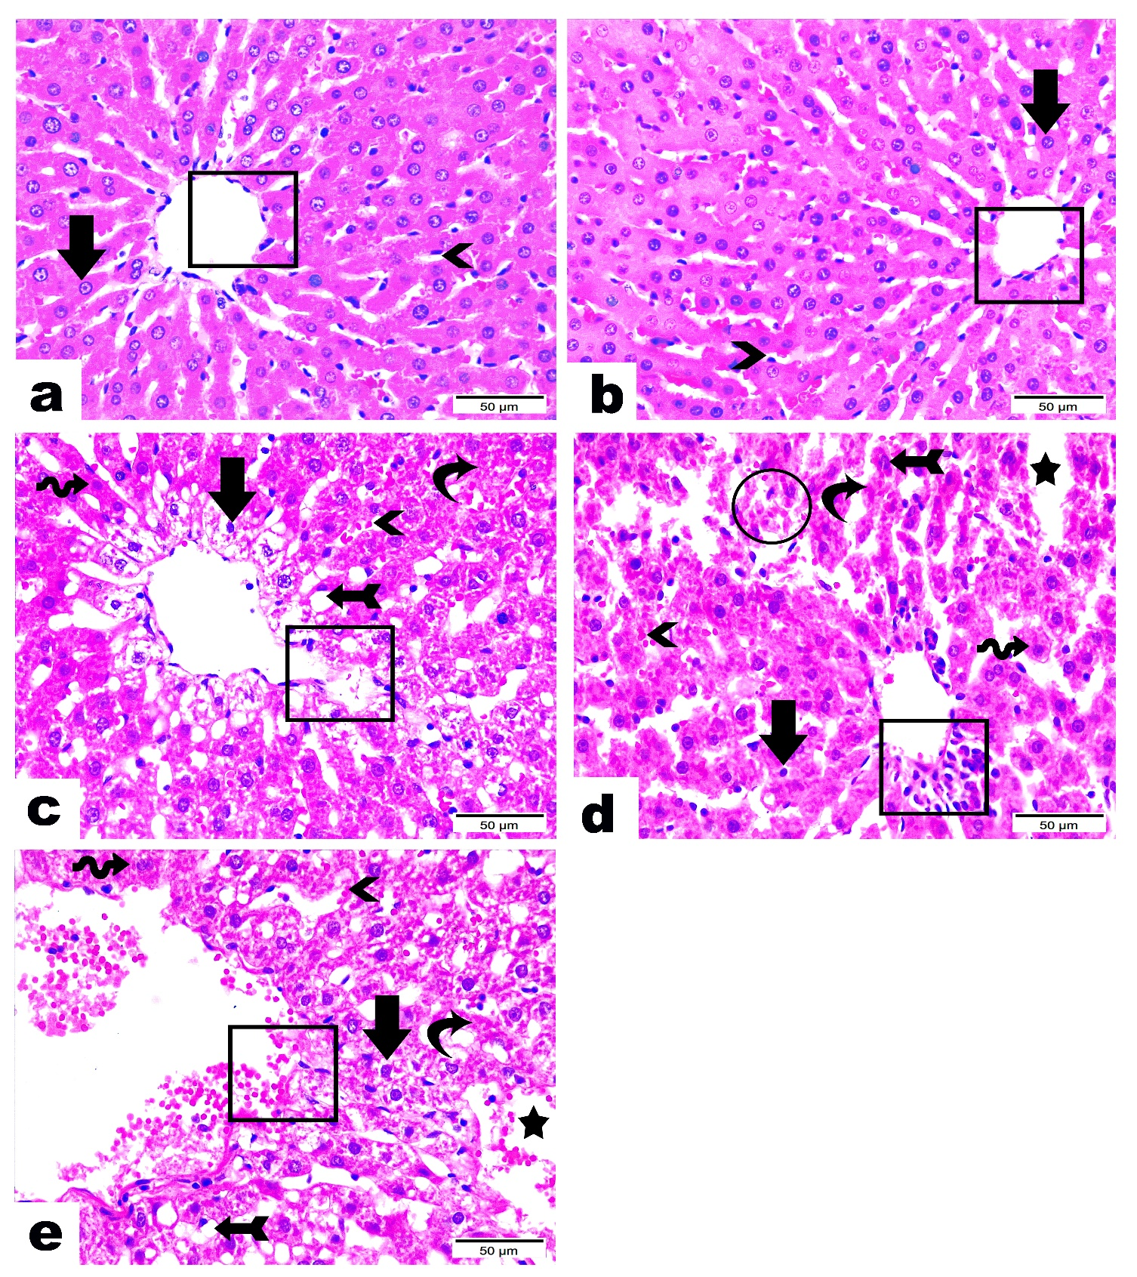**Figure 3.** Liver histoarchitecture after treatment with FU and/or Cd.Cr-water group (a) and Cr-oil group (b) show typical hepatic structure with intact endothelial lining of central vein (rectangles), hepatic cords appeared with their regular organization, lined with light and vesicular hepatocytes (arrows), hepatic sinusoids presented between hepatic cords with its usual structure (arrowheads)**.** FU group (c) demonstrated degeneration along hepatic tissue with degenerated central vein endothelial lining (rectangle), hepatocytes showed hydropic degeneration, deep basophilic apoptotic nuclei (arrow), and others with deep acidophilic cytoplasm (wave arrow). Hepatic sinusoids have severed congestion (arrowhead), microvascular steatosis (arrow with tail), additionally some necrotic areas (curvy arrow). Cd group (d) marking moderate injury along hepatic tissue with loss of hepatic organization with degeneration of hepatic cords (circle), degenerated central vein endothelial lining with inflammatory cells infiltration around it (rectangle). Hepatocytes show deep basophilic apoptotic nuclei (arrow), others showed hypertrophy, increasing cytoplasmic/nuclear ratio, and deep acidophilic cytoplasm (wave arrow), also seen with karyolitic changes (arrow with tail). Hepatic sinusoids appeared with severe congestion (arrowhead), additionally, some necrotic area is seen (curvy arrow), notice also interstitial edema that leads to dispersion between hepatic cords (star). FU+Cd group (e) displays severe hepatic injury with severe congestion, degeneration of central vein endothelial lining (rectangle), microvascular steatosis (arrow with tail), some hepatocytes show hydropic degeneration (arrow), while others with karyolitic nuclei and deep eosinophilic cytoplasm (wave arrow). Hepatic sinusoids exhibited dilatation and congestion (arrowhead), additionally, interstitial edema leading to dispersion between hepatic cords (star). (Bars = 50 μm).

**3.4. Immunohistochemical study:**

Here, we investigated the apoptotic effects caused by FU, Cd, or their combination (FU+Cd) on liver tissue. Changes in PCNA and TNF-α expressions in liver tissues in the nuclei and/or cytoplasm are illustrated in **Figures 4** and **5**, respectively. FU group or Cd group displaying a moderate positive nuclear and cytoplasmic expression of PCNA and TNF-α in hepatocytes compared to control group. Moreover, co-treatment with both remedies exhibited intense positive nuclear and cytoplasmic expression of PCNA and TNF-α in hepatic tissue.

Scoring of PCNA and TNF-α expressions induced by FU and/or Cd in liver are depicted in **Figures 4f** and **5f,** respectively. The data obtained from the immunohistochemical scoring revealed that concurrent exposure to FU and Cd drastically aggravated the inflammatory and apoptotic process compared to their single exposure.

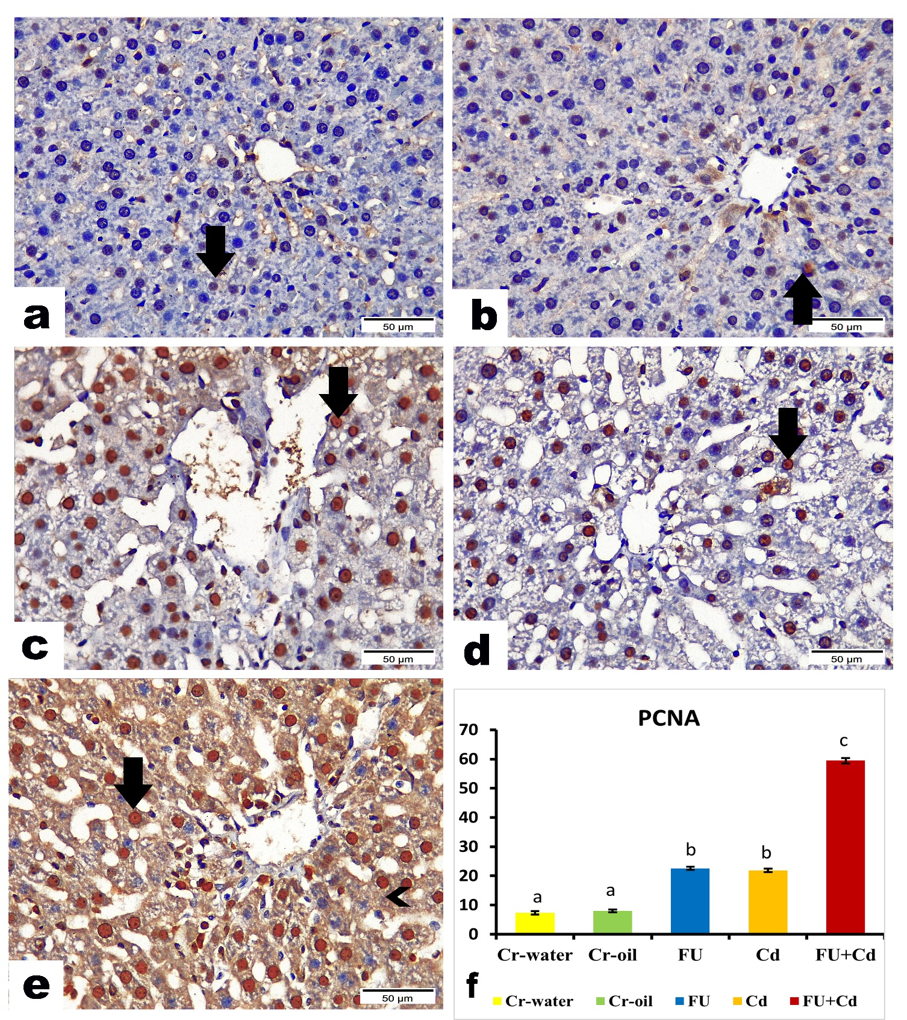

**Figure 4.** Effects of FU and/or Cd on the expression of PCNA in the liver tissue of rats. Cr-water group (a) and Cr-oil group (b) marking scarce positive nuclear expression of PCNA along hepatocytes (arrow). FU or Cd-treated rats displayed a moderate positive nuclear expression of PCNA in hepatocytes (arrow) (c and d, respectively). FU+Cd treated rats exhibiting intense positive nuclear expression of PCNA along hepatocytes (arrow), and positive cytoplasmic expression (arrowhead) (e). P< 0.05. Values were expressed as mean ± SE. The column chart shows the scoring of PCNA expression in liver tissue among different treated groups (f). FU, Furan; Cd, cadmium; arrow, nuclear expression of PCNA along hepatocytes; arrowhead, cytoplasmic expression of PCNA along hepatocytes. (Bars = 50 µm)

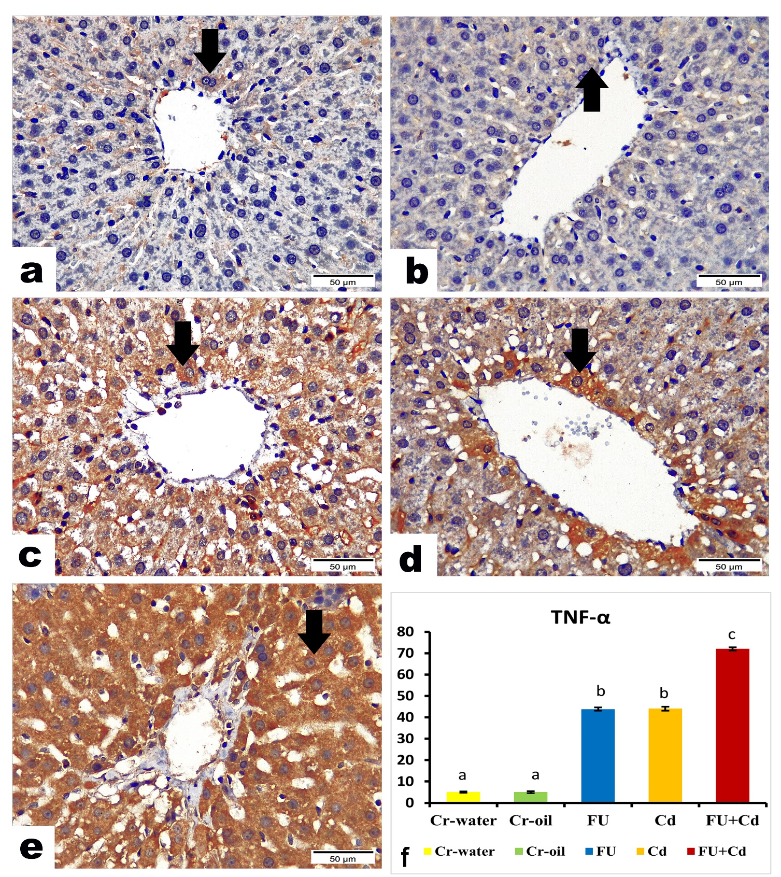

**Figure 5.** Effects of FU and/or Cd on the expression of TNF-α in the liver tissue of rats. control Cr-water group (a) and Cr-oil group (b) marking scarce positive nuclear expression of TNF-α along hepatocytes (arrow). FU- or Cd-treated rats showing moderate positive nuclear expression of TNF-α in hepatocytes (arrow) (c and d, respectively). FU+Cd treated rats exhibiting intense positive nuclear expression of TNF-α along hepatocytes (arrow) (e). **Figure.5**fshows the lesion scoring of immunohistochemical alterations of hepatic cells among different treated groups. P< 0.05. Values were expressed as mean ± SE. The column chart shows the scoring of TNF-α expression in liver tissue among different treated groups (f). FU, Furan; Cd, cadmium; arrow, nuclear expression of TNF-α along hepatocytes. (Bars = 50 µm)

**4. DISCUSSION**

FU is a naturally occurringsubstance that may cause cancer and is found in many thermally driven processed foods having a number of negative impacts on biological systems **(Pandir, 2015; Uçar and Pandir, 2017)**. While Exposure to toxic metals has grown to be a global issue, particularly, Cd is a hazardous occupational and environmental pollutant that even at low exposure levels could be harmful to both humans and animals. It is the most dangerous metal that is found naturally in the environment including cigarette smoke, air, soil, water, food, and beverages **(Singh *et al.*, 2013)**.

FU is transformed by CYP2E1 into the cytotoxic metabolite BDA, which mediates FU toxicity by forming long-lasting bonds with proteins and nucleotides. Additionally, the metabolite promotes cell proliferation and uncouples mitochondrial oxidative phosphorylation as another feature of furan toxicity **(Selmanoǧlu *et al.*, 2012)**. Moreover, Cd has a greater affinity for compounds found within biological cells that contain sulfur, like glutathione (GSH), catalase (CAT), and metallothionein (MT). According to **Rani *et al*., (2014)**, the liver expresses significant levels of MT that is essential for the sequestration and detoxification of Cd. The primary modulatory mechanism of Cd-induced cytotoxicity is the disruption of molecules containing SH, especially those that are involved in detoxification and oxidative phosphorylation. The present investigation found that treatment with either FU or Cd alone or in combination led to hepatic dysfunctions marked by elevations in serum biochemical indicators as well as histological alterations.

According to our findings, the experimental rats' exposure to FU and Cd changed the redox balance in their livers. The loss of redox equilibrium resulted in oxidative damage to DNA, pro-inflammatory response, and apoptosis **(Pandir *et al*., 2016; Abdeen *et al*., 2019a; Das and Al-naemi, 2019; Gill *et al.*, 2022)**. It is widely recognized that when ROS level (hydrogen peroxide (H2O2), hydroxyl radicals (HO•), superoxide anions (O2¯)) above the endogenous antioxidant capacity, the cellular antioxidant state is altered, resulting in an oxidative stress instance. These processes culminated in the breakdown of mitochondrial redox hemostasis, accumulation of ROS, and subsequent activation of oxidative injury **(Murugavel and Pari, 2007)**.

Free radical' produced by oxidative stress damages nucleic acids, lipid membranes, and proteins, which results in cell death **(Sarkar *et al*., 2021)**. Antioxidant enzymes like CAT, GSH, SOD, and MDA can protect cellular components from the harm caused by free radicals. CAT speeds up the process by which H2O2 breaks down into water and oxygen. Fenton's reaction generates a lot of OH• from H2O2 in the event of CAT depletion, which immediately assaults the membrane lipid and increases the generation of lipid peroxidation and MDA **(Abdel-Daim and Abdeen, 2018)**. Since GSH directly scavenging ROS, it is the most significant sovereign antioxidant and is ubiquitous in every cell in the body **(Abdel-Daim *et al.*, 2021)**. Additionally, the endogenous enzyme SOD serves as the first line of defense against oxidative damage in mitochondria, which dismutase conversion of O2 • to O2 and H2O2, therefore squelching oxidative damage **(Abdeen *et al*., 2019b)**. The findings here demonstrated that oxidative stress played a crucial role in the hepatic damage caused by FU and Cd. This was demonstrated by the drop in CAT, GSH, and SOD content levels in rats subjected to FU and/or Cd but when concurrently administered together, higher significant hepatic oxidative damage occurred compared to other groups.

Alarmingly, MDA is a byproduct of lipid peroxidation, which can create unpredictable bonds with other compounds such as DNA and protein **(Uddin *et al.*, 2021)**. Similar to this claim, the results of the current investigation's results demonstrated a significant increase in MDA concentrations, indicating that FU and/or Cd-induced lipid peroxidation had damaged the liver cell's membrane and caused leakage of the efficient intracellular enzymes (AST, ALT, and ALP), which signify liver dysfunction, into the bloodstream **(Ibraheem *et al.*, 2016)**. The transaminases (AST and ALT) are utilized as an indicator of liver damage, with ALT being regarded as the gold standard which confirms liver dysfunction **(McGill, 2016).** Moreover, we noticed disturbed lipid metabolism as evidenced by higher triglyceride and cholesterol levels in the blood suggesting that there was liver damage after FU and/or Cd treatment as demonstrated by microvascular steatosis in hepatocytes shown in our histological finding of the liver. The outcomes of this investigation align with previous studies which found that FU induces hepatotoxic damage in liver tissue **(Kaya *et al*., 2019a; Owumi *et al*., 2022a)**. The present investigation further showed that Cd-induced hepatic injury, which was supported by histological data, but when administered in conjunction with FU, more substantial hepatic damage had occurred compared to other groups. These findings are in line with studies by **Samarghandian *et al*. ( 2015), Abdeen *et al*. ( 2019a), and Noor *et al*. ( 2022)** that show the substantial harm that causes to rat liver cells.

Increased generation of ROS is expected to cause an intensified inflammatory response because it triggers an intracellular signaling cascade, increases the expression of genes linked to inflammation, and releases inflammatory mediators **(Owumi *et al.*, 2020)**. According to mounting evidence, exposure to FU **(Owumi *et al*., 2022b)** andCd **(Elmallah *et al.*, 2017; Joardar *et al.*, 2019)** are linked to an inflammatory response. This is supported by the large rises in pro-inflammatory cytokines (TNF-α) in the hepatic tissue of rats subjected to FU and testicular tissue homogenates of Cd-intoxicated rats. These events initiate the apoptotic cascade.

Apoptosis is a regulated process of cell death that is influenced by many signals and metabolic processes. In the current study, the cellular apoptosis was significantly instigated after FU and/or Cd ‐treatment demonstrated by upregulation of PCNA protein expression in hepatic tissue in combined exposure than either substance alone. PCNA is thought to be a useful biomarker for cellular proliferation that controls the rates of DNA replication and the cell cycle. These data are consistent with the findings of **Awad *et al*. (2018)** who evinced evoke in the immunostaining for PCNA after FU exposure in hepatic tissues of rats, also in another study done by **Koyuturk *et al*. (2007)** who demonstrated Cd caused significant upregulation of PCNA protein expression in liver tissues of rats. This impact is thought to be caused by the generation of free radicals caused by FU and/or Cd, which accelerates the oxidation of DNA in hepatic cells.

**5. Conclusions**

The results of this study indicate that the combined administration of FU and Cd had greater toxicities than their individual exposure. Oxidative stress caused by increased production of ROS and MDA, as well as the depletion of endogenous antioxidant components along with inflammatory damage occur in liver tissue were the primary mechanisms attributed to this potentiated toxicity.

**Acknowledgments**

The authors deeply thank the Center of Excellence in Screening of Environmental Contaminants (CESEC), Department of Forensic Medicine and Toxicology, Benha University, Egypt for all the facilities provided for implementing this work.

**Conflict of interest**

The authors declare that they have no conflict of interest.

**Reference:**

Abdeen, A., Abou-Zaid, O. A., *et al.* (2019a) ‘Cadmium overload modulates piroxicam-regulated oxidative damage and apoptotic pathways’, *Environmental Science and Pollution Research*, 26(24), pp. 25167–25177. doi: 10.1007/s11356-019-05783-x.

Abdeen, A., Aboubakr, M., *et al.* (2019b) ‘Rosuvastatin attenuates piroxicam-mediated gastric ulceration and hepato-renal toxicity in rats’, *Biomedicine and Pharmacotherapy*, 110(November 2018), pp. 895–905. doi: 10.1016/j.biopha.2018.11.004.

Abdel-Daim, M. M. *et al.* (2021) ‘Fucoidan supplementation modulates hepato-renal oxidative stress and DNA damage induced by aflatoxin B1 intoxication in rats’, *Science of the Total Environment*, 768, p. 144781. Available at: https://doi.org/10.1016/j.scitotenv.2020.144781.

Abdel-Daim, M. M. and Abdeen, A. (2018) ‘Protective effects of rosuvastatin and vitamin E against fipronil-mediated oxidative damage and apoptosis in rat liver and kidney’, *Food and Chemical Toxicology*, 114, pp. 69–77. doi: 10.1016/j.fct.2018.01.055.

Alizadeh, M. *et al.* (2018) ‘Industrial furan and its biological effects on the body systems’, *Journal of Food Biochemistry*, 42(5), pp. 1–13. doi: 10.1111/jfbc.12597.

Amamou, F. *et al.* (2015) ‘Protective effect of olive oil and colocynth oil against cadmium-induced oxidative stress in the liver of Wistar rats’, *Food and Chemical Toxicology*, 78, pp. 177–184. Available at: https://doi.org/10.1016/j.fct.2015.01.001.

Awad, A. *et al.* (2018) ‘Differential susceptibility of kidneys and livers to proliferative processes and transcriptional level of the genes encoding desmin, vimentin, connexin 43, and nestin in rats exposed to furan’, *Ecotoxicology and Environmental Safety*, 162, pp. 235–244. Available at: https://doi.org/10.1016/j.ecoenv.2018.07.003.

Bao, R., Zheng, S. and Wang, X. (2017) ‘Selenium protects against cadmium-induced kidney apoptosis in chickens by activating the PI3K/AKT/Bcl-2 signaling pathway’, *Environmental Science and Pollution Research*, 24, pp. 20342–20353. Available at: https://doi.org/10.1007/s11356-017-9422-6.

Batool, Z. *et al.* (2021) ‘A review on furan: Formation, analysis, occurrence, carcinogenicity, genotoxicity and reduction methods’, *Critical Reviews in Food Science and Nutrition*, 61(3), pp. 395–406. doi: 10.1080/10408398.2020.1734532.

Dai, X. *et al.* (2018) ‘Alterations of mitochondrial antioxidant indexes and apoptosis in duck livers caused by Molybdenum or/and cadmium’, *Chemosphere*, 193, pp. 574–580. doi: 10.1016/j.chemosphere.2017.11.063.

Das, S. C. and Al-naemi, H. A. (2019) ‘Cadmium Toxicity : Oxidative Stress , Inflammation and Tissue Injury’, *Occupational Diseases and Environmental Medicine*, pp. 144–163. doi: 10.4236/odem.2019.74012.

Delost, M. D. *et al.* (2018) ‘From Oxiranes to Oligomers: Architectures of U.S. FDA Approved Pharmaceuticals Containing Oxygen Heterocycles’, *Journal of Medicinal Chemistry*, 61(24), pp. 10996–11020. doi: 10.1021/acs.jmedchem.8b00876.

Elmallah, M. I. Y. *et al.* (2017) ‘Protective effect of Fragaria ananassa crude extract on cadmium-induced lipid peroxidation, antioxidant enzymes suppression, and apoptosis in rat testes’, *International journal of molecular sciences*, 18(5), p. 957. Available at: https://doi.org/10.3390/ijms18050957.

Gill, S. *et al.* (2022) ‘Proteomic Analysis of Subchronic Furan Exposure in the Liver of Male Fischer F344 Rats’, *Toxicologic Pathology*, 50(1), pp. 47–59. Available at: https://doi.org/10.1177/01926233211056859.

Husøy, T. *et al.* (2019) ‘Risk assessment of furan exposure in the Norwegian population’, *Eur J Nutr Food Safe*, 11, pp. 44–46. Available at: doi: 10.9734/EJNFS/2019/v11i130128.

Ibraheem, A. S. *et al.* (2016) ‘Single or combined cadmium and aluminum intoxication of mice liver and kidney with possible effect of zinc’, *The Journal of Basic & Applied Zoology*, 77(2016), pp. 91–101. doi: 10.1016/j.jobaz.2016.12.004.

Joardar, S. *et al.* (2019) ‘Rosmarinic acid attenuates cadmium-induced nephrotoxicity via inhibition of oxidative stress, apoptosis, inflammation and fibrosis’, *International Journal of Molecular Sciences*, 20(8), p. 2027. Available at: https://doi.org/10.3390/ijms20082027.

Kaya, E., Yılmaz, S. and Ceribasi, S. (2019a) ‘Protective role of propolis on low and high dose furan-induced hepatotoxicity and oxidative stress in rats’, *Journal of Veterinary Research*, 63(3), p. 423. Available at: doi:10.2478/jvetres-2019-0054.

Kaya, E., Yılmaz, S. and Ceribasi, S. (2019b) ‘Protective role of propolis on low and high dose furan-induced hepatotoxicity and oxidative stress in rats’, *Journal of Veterinary Research (Poland)*, 63(3), pp. 423–431. doi: 10.2478/jvetres-2019-0054.

Kousar, K. *et al.* (2022) ‘Biomedicine & Pharmacotherapy Hepatoprotective role of vitexin against cadmium-induced liver damage in male rats : A biochemical , inflammatory , apoptotic and histopathological investigation’, *Biomedicine & Pharmacotherapy*, 150, p. 112934. doi: 10.1016/j.biopha.2022.112934.

Koyuturk, M. *et al.* (2007) ‘The potential role of combined anti-oxidants against cadmium toxicity on liver of rats’, *Toxicology and Industrial Health*, 23(7), pp. 393–401. Available at: https://doi.org/10.1177/0748233707081907.

Kumar, A. *et al.* (2021) ‘Biomedicine & Pharmacotherapy Protective effect of eugenol on hepatic inflammation and oxidative stress induced by cadmium in male rats’, *Biomedicine & Pharmacotherapy*, 139(December 2020), p. 111588. doi: 10.1016/j.biopha.2021.111588.

Liu, J. *et al.* (2018) ‘Activity of MPF and expression of its related genes in mouse MI oocytes exposed to cadmium’, *Food and Chemical Toxicology*, 112, pp. 332–341. Available at: https://doi.org/10.1016/j.fct.2017.12.046.

Lu, D. and Peterson, L. A. (2010) ‘Identification of furan metabolites derived from Cysteine− cis-2-Butene-1, 4-dial− Lysine cross-links’, *Chemical research in toxicology*, 23(1), pp. 142–151. Available at: https://doi.org/10.1021/tx9003215.

McDaniel, L. P. *et al.* (2012) ‘Genotoxicity of furan in Big Blue rats’, *Mutation Research/Genetic Toxicology and Environmental Mutagenesis*, 742(1–2), pp. 72–78. Available at: https://doi.org/10.1016/j.mrgentox.2011.12.011.

McGill, M. R. (2016) ‘The past and present of serum aminotransferases and the future of liver injury biomarkers.’, *EXCLI journal*, 15, pp. 817–828. doi: 10.17179/excli2016-800.

Murugavel, P. and Pari, L. (2007) ‘Effects of diallyl tetrasulfide on cadmium-induced oxidative damage in the liver of rats’, *Human and Experimental Toxicology*, 26(6), pp. 527–534. doi: 10.1177/0960327107073810.

Nair, A. R. *et al.* (2013) ‘Cadmium-Induced Pathologies: Where Is the Oxidative Balance Lost (or Not)?’, *International Journal of Molecular Sciences*, pp. 6116–6143. doi: 10.3390/ijms14036116.

Noor, K. K. *et al.* (2022) ‘Hepatoprotective role of vitexin against cadmium-induced liver damage in male rats: A biochemical, inflammatory, apoptotic and histopathological investigation’, *Biomedicine and Pharmacotherapy*, 150, p. 112934. doi: 10.1016/j.biopha.2022.112934.

Owumi, S. E. *et al.* (2020) ‘Luteolin abates reproductive toxicity mediated by the oxido-inflammatory response in Doxorubicin-treated rats’, *Toxicology research and application*, 4, p. 2397847320972040. Available at: https://doi.org/10.1177/2397847320972040.

Owumi, S. E., Arunsi, U. O., *et al.* (2022a) ‘Accidental lead in contaminated pipe-borne water and dietary furan intake perturbs rats’ hepatorenal function altering oxidative, inflammatory, and apoptotic balance’, *BMC Pharmacology and Toxicology*, 23(1), pp. 1–17. doi: 10.1186/s40360-022-00615-0.

Owumi, S. E., Bello, S. A., *et al.* (2022b) ‘Protocatechuic acid protects against hepatorenal toxicities in rats exposed to Furan’, *Drug and Chemical Toxicology*, 45(4), pp. 1840–1850. doi: 10.1080/01480545.2021.1890109.

Pandir, D. (2015) ‘Assessment of the DNA damage in human sperm and lymphocytes exposed to the carcinogen food contaminant furan with comet assay’, *Brazilian Archives of Biology and Technology*, 58, pp. 773–780. Available at: https://doi.org/10.1590/S1516-89132015050269.

Pandir, D., Unal, B. and Bas, H. (2016) ‘Lycopene Protects the Diabetic Rat Kidney Against Oxidative Stress-mediated Oxidative Damage Induced by Furan’, *Brazilian Archives of Biology and Technology*, 59(December), pp. 1–12. doi: 10.1590/1678-4324-2016150794.

Poli, V. *et al.* (2022) ‘Amelioration of Cadmium-Induced Oxidative Damage in Wistar Rats by Vitamin C, Zinc and N-Acetylcysteine’, *Medical sciences (Basel, Switzerland)*, 10(1). doi: 10.3390/medsci10010007.

Rahimzadeh, Mehrdad Rafati *et al.* (2017) ‘Cadmium toxicity and treatment: An update’, *Caspian journal of internal medicine*, 8(3), p. 135. Available at: doi: 10.22088/cjim.8.3.135.

Rani, A. *et al.* (2014) ‘Cellular mechanisms of cadmium-induced toxicity: A review’, *International Journal of Environmental Health Research*, 24(4), pp. 378–399. doi: 10.1080/09603123.2013.835032.

Samarghandian, S. *et al.* (2015) ‘Effect of chronic exposure to cadmium on serum lipid, lipoprotein and oxidative stress indices in male rats’, *Interdisciplinary toxicology*, 8(3), p. 151. https://doi.org/10.1515/intox-2015-0023.

Sarkar, S., Singh, R. P. and Bhattacharya, G. (2021) ‘Exploring the role of Azadirachta indica (neem) and its active compounds in the regulation of biological pathways: an update on molecular approach’, *3 Biotech*, 11(4), p. 178. Available at: https://doi.org/10.1007/s13205-021-02745-4.

Seif, M. M. *et al.* (2019) ‘Hepato-Renal protective Effects of Egyptian Purslane Extract against Experimental Cadmium Toxicity in Rats with Special Emphasis on the Functional and Histopathological Changes’, *Toxicology Reports*, 6(March), pp. 625–631. doi: 10.1016/j.toxrep.2019.06.013.

Selmanoǧlu, G. *et al.* (2012) ‘Toxicity of food contaminant furan on liver and kidney of growing male rats’, *Environmental Toxicology*, 27(10), pp. 613–622. doi: 10.1002/tox.20673.

Sharma, N. (2014) ‘Biologicals’, *Biological Controls for Preventing Food Deterioration*, pp. 1–25. Available at: https://doi.org/10.1002/9781118533024.ch1.

Singh, N. *et al.* (2013) ‘Role of Green Tea on Cadmium Toxicity on Haematological Profile of Albino Rats’, *American Journal of Phytomedicine and Clinical Therapeutics*, 1(5), pp. 537–542.

Uçar, S. and Pandir, D. (2017) ‘Furan induced ovarian damage in non-diabetic and diabetic rats and cellular protective role of lycopene’, *Archives of gynecology and obstetrics*, 296, pp. 1027–1037. Available at: https://doi.org/10.1007/s00404-017-4521-7.

Uddin, M. J. *et al.* (2021) ‘Pharmacotherapy against oxidative stress in chronic kidney disease: Promising small molecule natural products targeting nrf2-ho-1 signaling’, *Antioxidants*, 10(2), p. 258. https://doi.org/10.3390/antiox10020258

Zhang, H. and Reynolds, M. (2019) ‘Cadmium exposure in living organisms: A short review’, *Science of the Total Environment*, 678, pp. 761–767. Available at: https://doi.org/10.1016/j.scitotenv.2019.04.395.